**Artificial Intelligence**

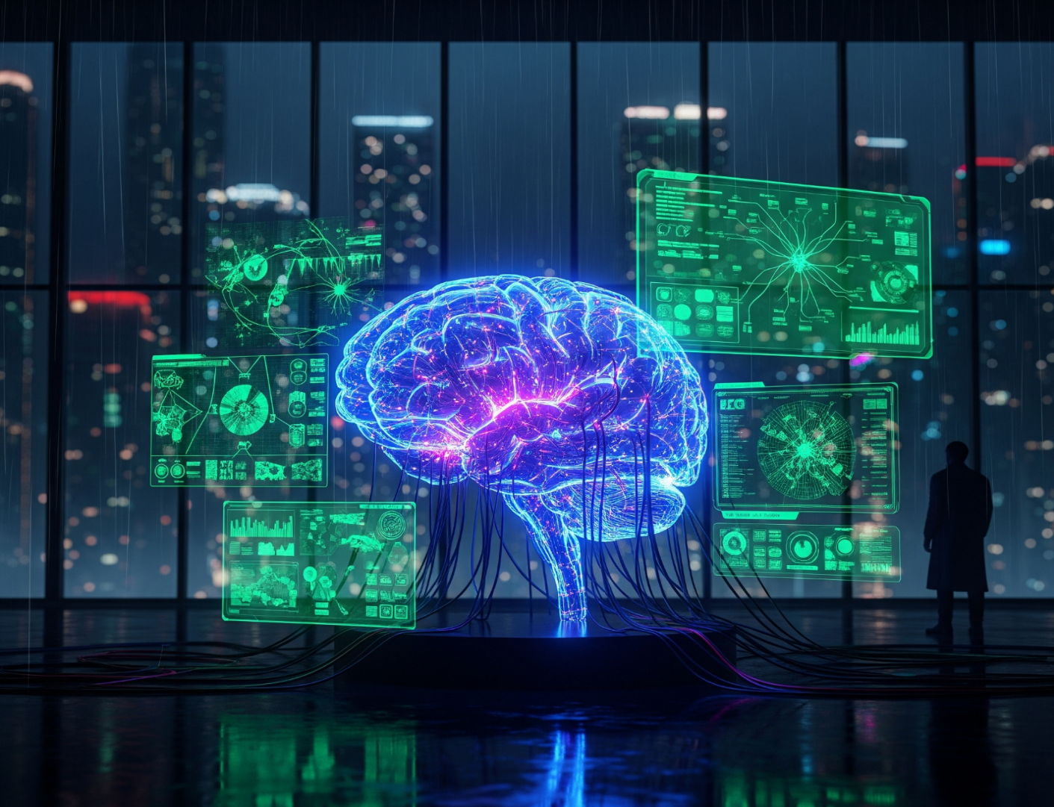

- **Prepared By**

**Fasieha**

**Introduction**

When we hear the term **AI**, the first thing that often comes to mind is GPT—a tool that helps us with daily academic and personal tasks. But

“**Artificial Intelligence is far more than just GPT models”**

It isn't limited to simple automation either; rather, it represents one of the most groundbreaking technological frontiers in human history.

AI goes beyond teaching machines to mimic human thought and reasoning—it's the driving force behind innovations such as self-driving cars, intelligent assistants, advanced medical diagnostics, and predictive systems. More than just a tool, AI is shaping the way we interact with technology, unlocking possibilities that were once unimaginable.

Artificial intelligence is one of the most advanced technologies because it allows computers and software to do tasks that usually need human thinking. From playing games to understanding speech to finding patterns, AI can handle all of this and much more. These systems can also learn on their own, without constant human guidance, and they can quickly process huge amounts of data to make decisions or take actions automatically.

With many possessing only a limited understanding of what AI can do for them in a general sense, the complexities of how AI operates are vast and the possibilities of what AI could achieve in the future seem endless.

As a way to determine whether an AI model has reached the capability of mimicking human thought processes, they are often assessed against the Turing Test. As yet, there has been no AI model that has officiallypassed the Turing Test – ChatGPT creators claimed their model passed the Turing Test, though this has not yet been independently verified.

Because the concept of ‘intelligence’ itself is difficult to define in relation to AI, it can be broadly outlined in **three** ways: Artificial Narrow Intelligence, Artificial General Intelligence, and Artificial Superintelligence.

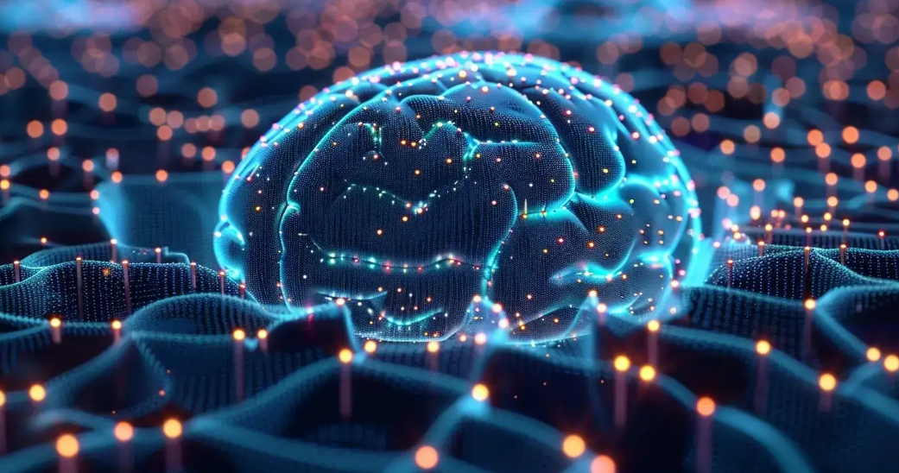

**Artificial Narrow Intelligence (ANI):** Sometimes called Weak AI, has limited application and succeeds at performing single tasks very well. Narrow AI operates within a narrow context and is an imitation of human intelligence applied to a specifically designed problem (e.g. changing voice to text). Narrow AI models include: Siri and Alexa; Grammarly; social media filters; self-driving cars. At present, ANI is the only type of AI in existence.

**Artificial General Intelligence (AGI)**: or Strong AI, is a machine that is considered to be ‘on par’ with human intelligence, simulating behaviours with the ability to learn and apply its intelligence to solve any problem. AGI would behave in a way that is nearly identical to that of a human in any given situation; AGI would even possess the ability to have and understand emotions. However, this type of AI remains theoretical and doesn’t yet exist – rest assured, though, there are many companies accelerating efforts towards achieving such advanced levels of AI.

**Artificial Superintelligence (ASI)**: It would far surpass its predecessors, with the ability to become cognisant and exceedthe intelligence of humans. While such capabilities might seem like the plot to a futuristic, dystopian novel, ASI is presently hypothetical and not a level of advancement that we are likely to encounter in our lifetime.

**“Artificial Intelligence is going to change the world more than anything else in the history of our civilization. More than electricity, more than the internet”**

-Stephen Hawking

Many people have a fear of AI systems becoming too intelligent, with some going so far as to say that robots could one day “take over the world”. In response to this matter, many governments and industries are already taking steps to address the ethical and safety concerns of AI systems.

AI is a complex and multifaceted technology that features greatly in our everyday lives. The AI systems that exist are already advanced, but the possibilities for future innovation of AI systems are seemingly endless. An AI system is only as ‘smart’ as the algorithm that it has been programmed with; highly-skilled programmers across many industries will be highly sought after, and lucrative salaries are likely to be used to entice the best of the best. With ethical and safety issues of AI increasingly concerning many governments and industry leaders, it is clear that AI is here to stay and is poised to make a difference to the world we live in – hopefully for the better.

**The Evolution of AI**

Imagine a world where machines can think, learn, and make decisions just like us. Sounds fascinating, right? Have you ever wondered how your phone understands your voice, how Netflix knows exactly what movies you’ll enjoy, or how self-driving cars operate? The evolution of AI is making this a reality! That’s all thanks to Artificial Intelligence (AI).

Today, AI is used everywhere! Google Assistant and Siri understand what we say. Artificial intelligence helps doctors find diseases faster and even makes online shopping feel more personal. Big companies like Amazon, Google, and Tesla use AI to make their products smarter and more useful for us.

But how did AI reach this point? Can you imagine how machines can learn, understand, and make decisions like humans? In this article, we’ll explore the fascinating journey of AI.

**The Birth of AI (1950-1970)**

In 1950, British mathematician Alan Turing introduced a groundbreaking idea—the **Turing Test**. He asked a simple yet powerful question: Can machines think like humans? This idea became the foundation of AI research and set the stage for everything we see today.

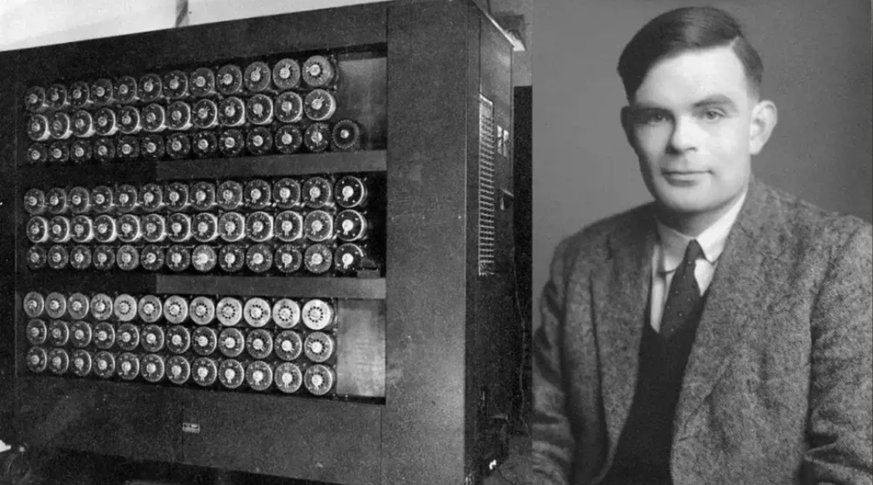

In 1956, **John McCarthy** and a group of researchers came together at the **Dartmouth Conference** and introduced a new term—**Artificial Intelligence (AI).** This event is considered the official starting point of AI as a field of study.

In the early days of AI, scientists built programs that could solve mathematical problems and even play simple games like chess. It was an exciting start, but there was one big challenge: The progress was very slow because of limited computational power.

## Struggles and Growth of ****Artificial Intelligence**** (AI) (1970-1990)

## In 1970, AI made a big leap with Expert Systems—programs designed to think like human experts in fields like medicine and engineering. They were impressive and useful, but there was a catch—they were too expensive and hard to maintain.

## 

## In the **1980s**, AI faced a tough time. People had **high expectations**, but the technology **wasn’t advancing fast enough**.**** As a result, funding dropped, and progress **slowed down massively.** This period is known as the **“AI Winter.”**

## The AI Boom : Evolution of AI (Period 1990-2010)

In the 1990s, AI took a big step forward with the rise of neural networks, a technology inspired by the human brain. These networks gave AI the ability to recognize patterns, learn from data, and improve over time. This meant machines could now process information more like humans.

In **1997**, **IBM’s Deep Blue** made history by defeating world chess champion **Garry Kasparov.** This groundbreaking victory proved that AI could handle **complex decision-making** and even compete with the best human minds. It was a major milestone in AI development, showcasing its growing intelligence and potential.

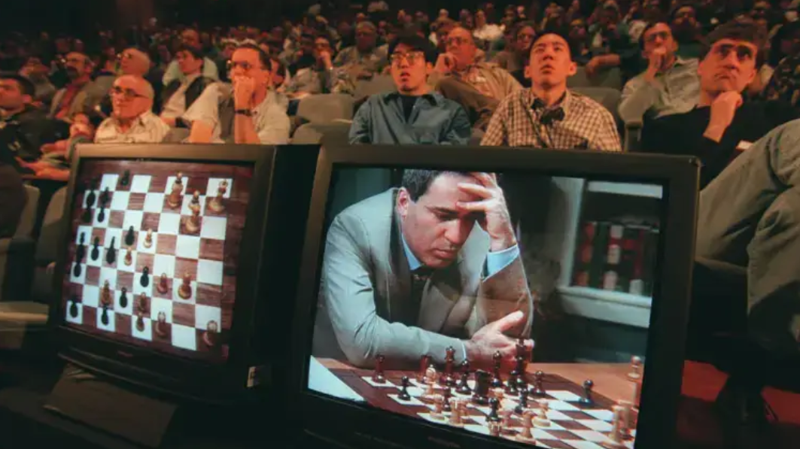

AI started being used in**speech recognition, robotics, and data processing.** Companies like **Google and Microsoft** saw its potential and started investing heavily in AI research.

## The Modern AI Revolution (2010 – 2019)

With the rise of big data and improved computing power, deep learning became the backbone of AI advancements. AI systems started outperforming humans in various tasks.

In 2011, IBM Watson won the Jeopardy! quiz show. It proved that AI could understand and process language like humans. This was a big breakthrough for AI!

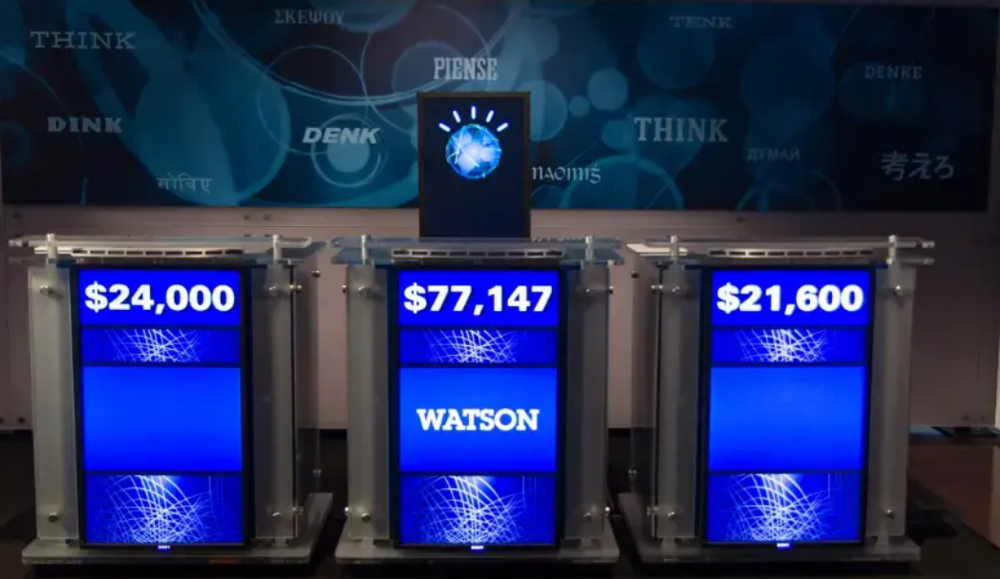

In **2016**, Google DeepMind’s AlphaGo defeated Go champion **Lee Sedol.** This proved that AI could master even the most complex strategy games, showing its incredible learning ability.

With the development of AI-powered virtual assistants like **Siri, Alexa, and Google Assistant,** AI became a part of daily life. These smart assistants could **answer questions, set reminders, and even crack jokes!** They made interacting with technology easier, smarter, and more fun.

In the 2020s, OpenAI introduced GPT-3 and GPT-4. Now, Artificial Intelligence (AI) can write stories, answer questions, and generate content with amazing accuracy. Chatbots became smarter, and creative tools became more advanced. AI started feeling more natural, and interactions felt smoother and more human-like than ever before!

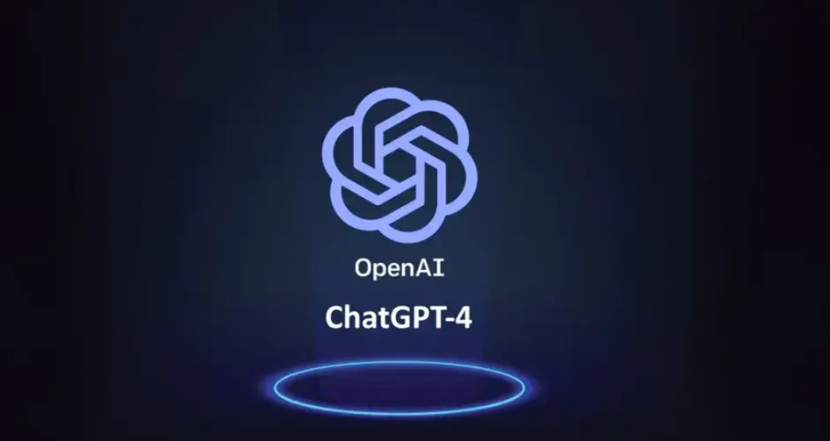

## The Difference Between Generative AI and Agentic AI

## AI is growing fast, but not all AI works the same way. There are two important types of Artificial Intelligence (AI) ****Generative AI**** and ****Agentic AI****. What makes them different? Let’s find out!

**Generative AI – The Creative Genius**

Generative AI is like an artist or writer. It creates things—text, images, music, videos—by learning from patterns in data. It doesn’t think on its own but follows instructions to produce amazing, human-like content.

* Examples: ChatGPT, DALL·E, MidJourney, Deep Seek
* Uses: Writing stories, generating art, making music

**Agentic AI – The Independent Thinker**

Agentic AI, on the other hand, doesn’t just create—it acts. It can make decisions, adapt, and even take action on its own without constant human input. Think of it as an AI assistant that not only answers your questions but also plans, learns, and solves problems in real time.

* Examples: Replit Ai, AgentGPT,Self-driving cars, smart automation bots, AI-powered assistants
* Uses: Managing tasks, optimizing workflows, making real-time decisions

## The Future of AI: What’s Next After 2025?

## AI is advancing faster than ever, and the future looks even more exciting. Here’s what we can expect:

## 

* **Smarter AI Assistants** – Virtual assistants will become more human-like, understanding emotions and handling complex tasks.
* **AI in Healthcare** – Faster disease detection, AI-powered surgeries, and personalized treatments will improve healthcare.
* **Fully Autonomous AI** – AI will make decisions and take actions without human input, from smart homes to self-driving cities.
* **Better Creativity** – AI will create more realistic art, music, and movies, blurring the line between human and machine creativity.
* **Ethical AI** – As AI grows, so will concerns about fairness, bias, and privacy, leading to stronger regulations and responsible AI development.

The future of AI isn’t just about smarter machines—it’s about transforming the way we live, work, and interact with technology.

**Conclusion**

Artificial Intelligence has evolved from a mere concept in the minds of visionaries like Alan Turing to a powerful force that influences nearly every aspect of modern life. From early expert systems and chess-playing machines to today’s generative and agentic AI, the journey of AI reflects continuous innovation driven by human curiosity and technological progress.

While current AI is mostly limited to **Artificial Narrow Intelligence**, the pursuit of **AGI** and even **ASI** highlights humanity’s ambition to push boundaries further. The rapid progress we see today—in healthcare, communication, automation, and creativity—demonstrates that AI is no longer a futuristic idea but a present-day reality shaping how we live, work, and interact.

However, with great potential comes great responsibility. Ethical challenges, security risks, and the fear of machines becoming “too intelligent” remind us that the development of AI must be guided by accountability, fairness, and safety.

Looking ahead, AI promises not only smarter systems and advanced problem-solving but also a profound transformation of society. If developed responsibly, Artificial Intelligence has the power to become one of the most impactful innovations in human history—reshaping industries, improving lives, and driving us toward a smarter and more connected future.

**References:**

* [**https://www.bbc.com/news/entertainment-arts-67271252**](https://www.bbc.com/news/entertainment-arts-67271252)
* [**https://en.wikipedia.org/wiki/Artificial_intelligence**](https://en.wikipedia.org/wiki/Artificial_intelligence)
* [**https://gsmbangla.com/how-ai-started-the-evolution-of-ai/**](https://gsmbangla.com/how-ai-started-the-evolution-of-ai/)